**Activity based**

**Project 1 Report on**

**Database Management Systems**

**Submitted to Vishwakarma University, Pune**

**Under the Initiative of**

**Contemporary Curriculum, Pedagogy, and Practice (C2P2)**

**By**

**Atharva Shevate**

**SRN No : 202201727**

**Roll No : 02**

**Div : E**

**Second Year Engineering**

**Department of Computer Engineering**

**Faculty of Science and Technology**

**Academic Year**

**2023-2024**

**Design an ER Diagram for Student Registration and Grading System**

**Project Statement:**

Student registration and grading system

**ER diagram**

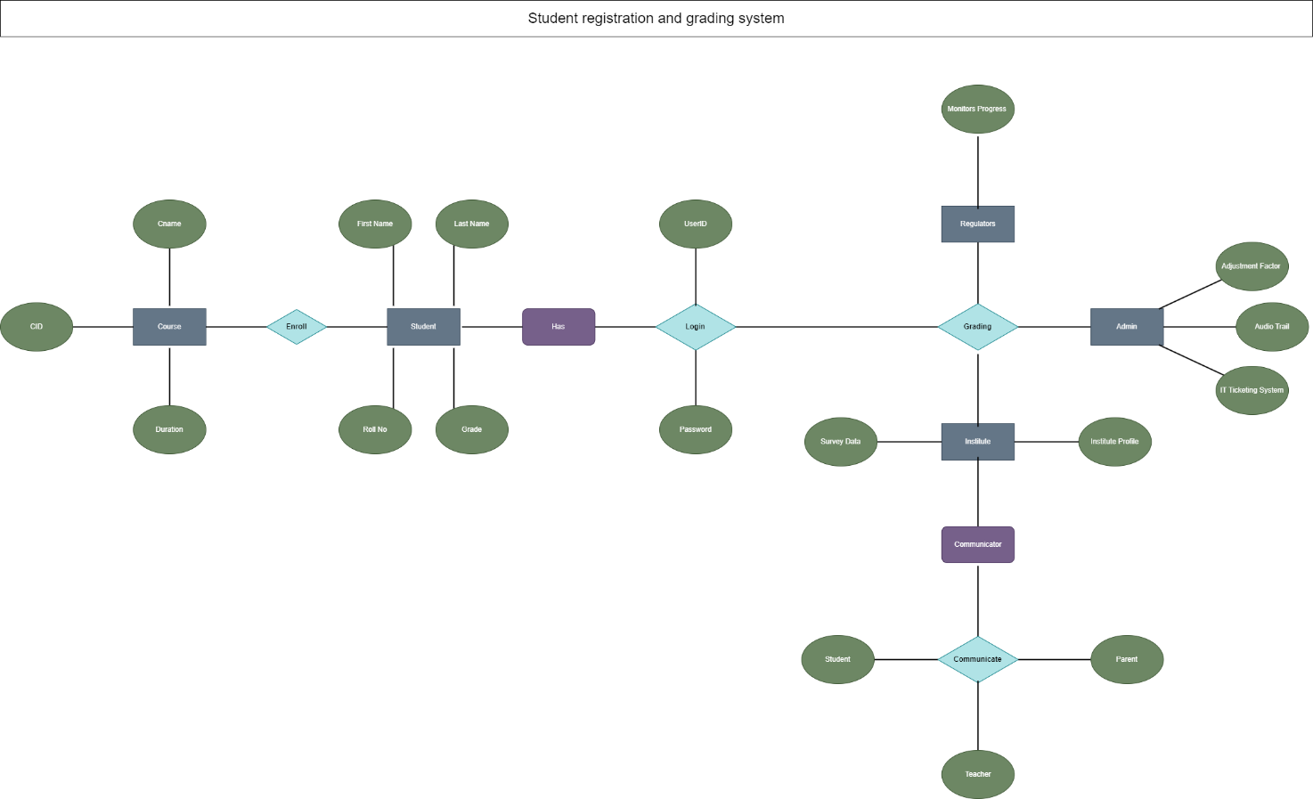

**Fig 1. ER Dig**

**Problem Description:**

A Student Registration and Grading System is designed to streamline the process of enrolling students into courses and managing their academic progress. Here's a brief problem description for such a system:

**1. Student Registration:**

- Allow students to register for courses online, providing necessary personal and academic information.

- Validate course prerequisites and availability during the registration process.

**2. Course Management:**

- Enable administrators to manage course information, including title, description, schedule, and availability.

- Implement a user-friendly interface for adding, updating, or removing courses.

**3. Grading System:**

- Define a grading system with letter grades, grade points, and corresponding performance descriptors.

- Automate the calculation of overall course grades based on assessments, exams, and assignments.

**4. User Authentication:**

- Develop a secure authentication system for students, instructors, and administrators.

- Implement role-based access control to restrict unauthorized access.

**5. Transcript Generation:**

- Generate electronic transcripts for students, detailing courses taken, grades obtained, and cumulative GPA.

- Ensure the accuracy and security of transcript data.

**6. Communication Platform:**

- Facilitate communication between students and instructors through the system.

- Send notifications for important events, deadlines, and announcements.

**7. Reporting and Analytics:**

- Provide administrators with reports on enrollment statistics, course popularity, and student performance.

- Implement analytics to identify trends and areas for improvement.

**8. Schedule Management:**

- Allow students to view their course schedules and make adjustments during the registration period.

- Ensure that there are no scheduling conflicts.

**9. Data Security:**

- Implement robust security measures to protect student information, grades, and system data.

- Comply with data protection regulations and standards.

**Project stage- I details:**

**1. Project Setup:**

- Choose a programming language (e.g., Java, Python, C#), database system (e.g., MySQL, SQLite), and development framework.

- Set up the project structure and version control (e.g., Git).

**2. Database Design:**

- Define the database schema to store student information, courses, and grades.

- Create tables for students with fields like student ID, name, contact details, and enrollment date.

- Establish tables for courses with relevant details and a grading system.

**3. User Authentication:**

- Develop a secure user authentication system for student registration and login.

- Implement password encryption for user account security.

**4. Basic Frontend:**

- Create a simple frontend interface with HTML, CSS, and possibly a frontend framework.

- Design registration and login forms for students.

**5. Student Registration:**

- Implement the functionality for students to register by providing necessary details.

- Validate and store student information securely in the database.

**6. Course Management:**

- Design a basic course management system to add, edit, or delete courses.

- Link courses to respective instructors if applicable.

**7. Gradebook:**

- Develop a basic gradebook section where instructors can input and update student grades for each course.

- Implement a simple grading system (e.g., letter grades, GPA).

**8. Backend APIs:**

- Develop backend APIs to handle student registration, login, course management, and gradebook operations.

- Ensure secure communication between the frontend and backend.

**9. Testing:**

- Perform basic testing for student registration, login, course management, and grade input functionalities.

- Identify and address any bugs or issues.

**10. Documentation:**

- Document the initial project setup, database schema, and basic functionalities.

- Provide a README file with instructions for setting up and running the project.

**11. Version Control:**

- Set up version control using tools like Git to track changes and facilitate collaboration.

**Conclusion :**

The Student Registration and Grading System efficiently manages student data, registration, and academic performance. It simplifies administrative tasks, enhances user experience, and ensures accurate and secure record-keeping. With streamlined processes for registration, grading, and reporting, the system promotes efficiency and transparency, contributing to an improved educational environment. Future stages may focus on additional features, scalability, and continuous improvement based on user feedback.